**MICROPROCESSOR & EMBEDDED SYSTEMS (Project 1 & Part-1)**

**Data Memory and Program Memory**

In the lab today, we experimented with installing, debugging, and becoming acquainted with the software Vivado and Xilinx ISE via NoMachine. Additionally, we began designing the program memory and data memory. As soon as we were comfortable with the first phase of our project, we attempted to construct Verilog code for both the memory and to create test benches to determine the waveforms needed to verify the code and design. The waveforms for the program and the data memory are shown in the screenshots that are linked below.

In *image 1.1*

**tbAddr_Bus** is the address that passes from the testbench.

**tbdata** is data that is successfully stored in program memory.

**addr** is a testbench variable given in testbench.

***Image 1.1***

In *image 1.2*

**tbAddr_Bus** is the address that passes from the testbench.

**tbDataIn** is data that is successfully stored in Data memory.

**addr & data** is a testbench variables given in testbench.

**RW** specifies the memory read or write operation.

In Our case RW = 1 for write and RW = 0 for Read.

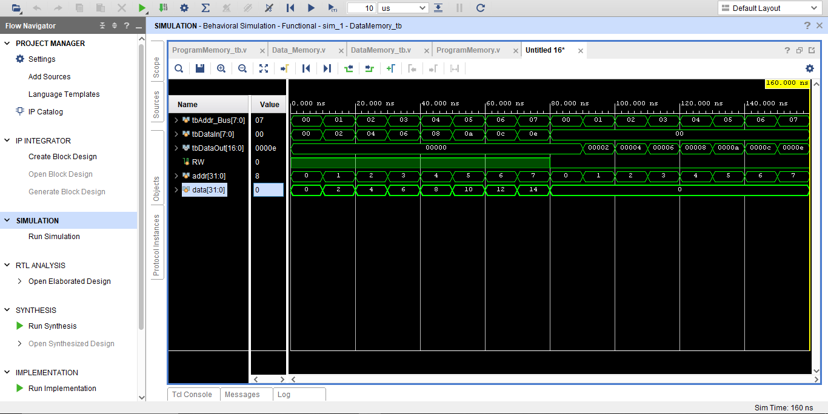

***Image 1.2***

I would design and simulate a synthesizable ALU (Arithmetic Logic Unit), Register File, and necessary Multiplexor as part of my next week’s implementation strategy. There are numerous requirements and inputs listed that must be fed to them. Therefore, I am looking forward to working with ALU's reg files and mux in the upcoming lab session on Thursday.

1. **What are the long formats of ROM, PROM, EPROM, and EEPROM? Explain briefly (2 or 3 lines) their pros, cons, and differences in a table. Also, consider Flash memory in your comparisons.**

|  |  |  |  |  |
| --- | --- | --- | --- | --- |
| **Memory Type** | **Long Format** | **Pros** | **Cons** | **Differences** |
| ROM | Read-Only Memory | - Non-volatile, retains data even after power is removed.  -Inexpensive | - Cannot be reprogrammed  - Data is permanent and cannot be modified | - Fixed data content  - Low cost |
| PROM | Programmable Read-Only Memory | - Can be programmed once by the user  - Non-volatile | - Cannot be reprogrammed  - More expensive than ROM | - Can be programmed once  - More expensive than ROM |
| EPROM | Erasable Programmable Read-Only Memory | - Can be reprogrammed multiple times  - Non-volatile | - Requires UV light to erase data  - More expensive than PROM | - Can be reprogrammed multiple times  - Requires UV light to erase data |
| EEPROM | Electrically Erasable Programmable Read-Only Memory | - Can be reprogrammed multiple times  - Non-volatile  - Can be erased electrically | - More expensive than EPROM  - Slower erase and write times | - Can be reprogrammed multiple times  - Can be erased electrically |
| Flash Memory | NAND Flash Memory | - Non-volatile  - Faster erase and write times than EEPROM  - Higher storage capacity | - Can wear out with multiple write/erase cycles  - More expensive than EEPROM | - Faster erase and write times  - Higher storage capacity  - Can wear out with multiple write/erase cycles |

1. **Why is stored data in the Program Memory larger than Data Memory (in this project)?**

Because program memory is used to store the permanent code or instructions of a microcontroller and data memory is used to temporarily store variable data and intermediate results during program execution, program memory (also known as flash memory) typically has more storage space than data memory (such as RAM).

Because it is intended to hold the code and instructions needed to run the microcontroller, which can be rather large, program memory has a larger capacity than data memory. The CPU can swiftly access and alter the variable data stored in data memory, on the other hand, because it is made to be quick and accessible. However, because data memory is volatile by nature, it’s stored.